**What is displayed in each of the interface screen:**

1. **Search Page**: This page is the starting page. Users could input anything they would like to check and click “GET START” would direct users to 2.Search Results Page.

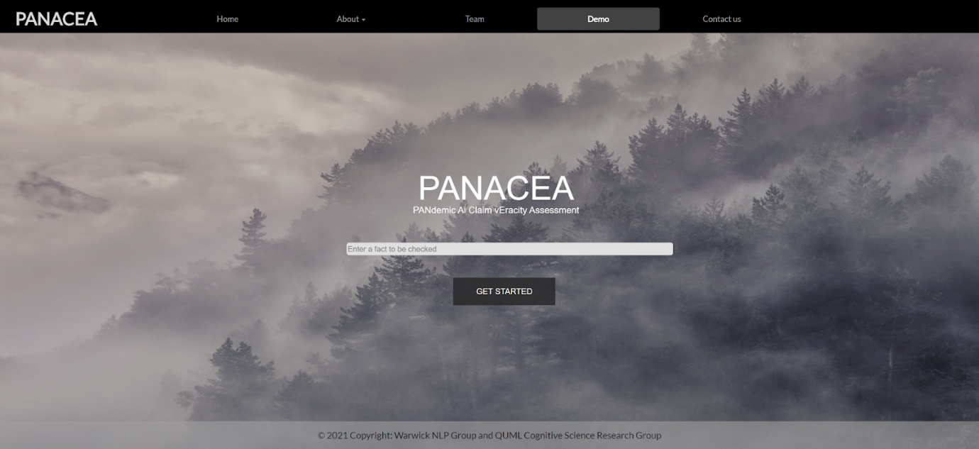

Since the back-end is not available right now, we have this demo page showing some static results.

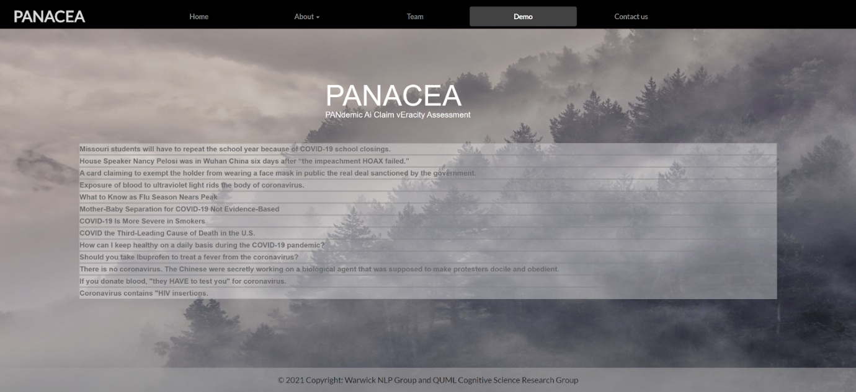

1. **Search Results Page**: List of results are sorted by relevant score and displayed. Users can choose to show relevant articles or relevant sentences. Users could lick any results they are interested in and it would direct to the corresponding 3. Article Details Page.

Sort by article: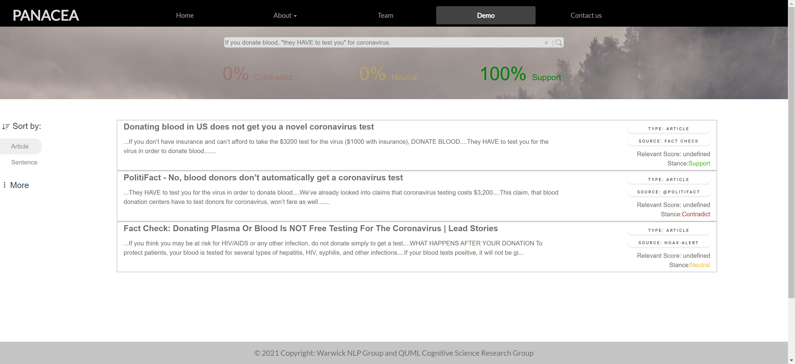

Sort by sentence:

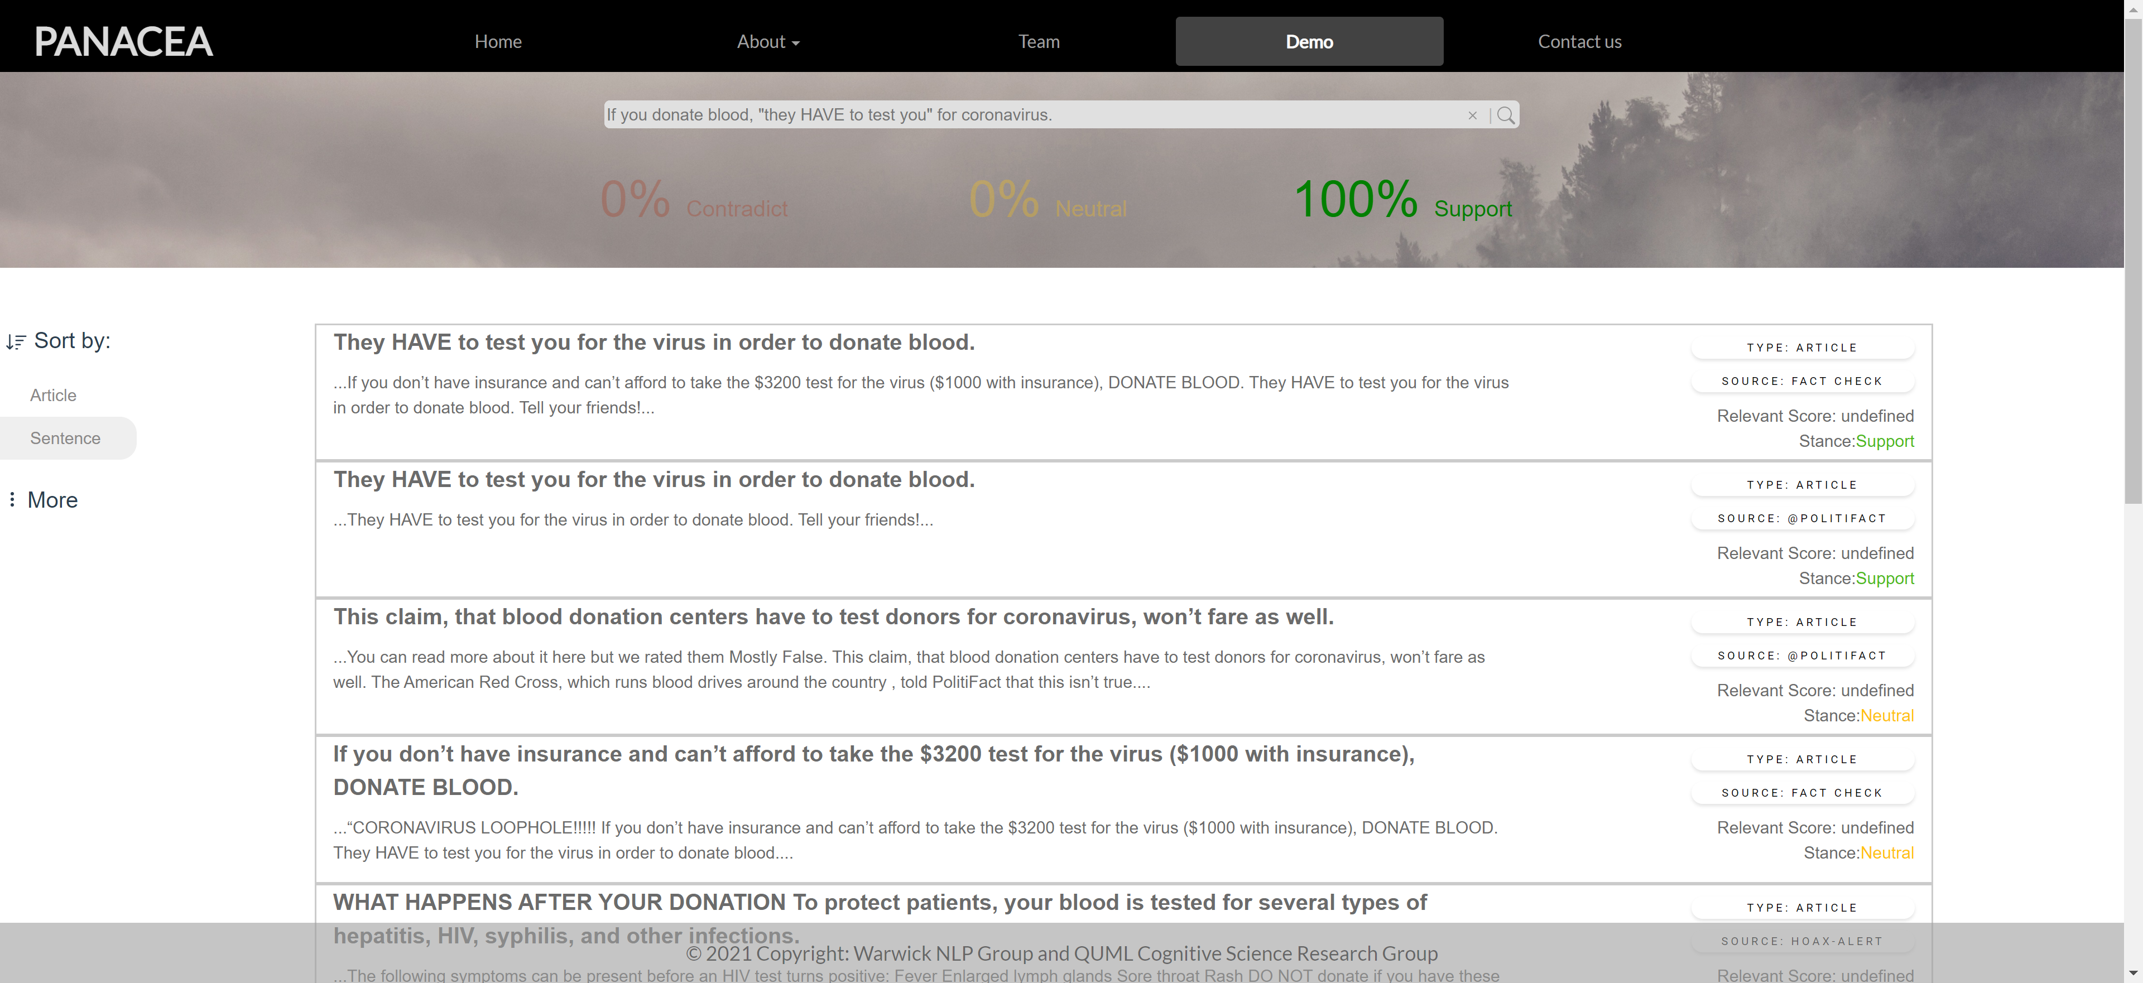

1. **Article Details Page**: this page including the details of chosen article from 2. Search Results Page, including the related article paragraph, pie chart of stance of the article, and the link to the original source page.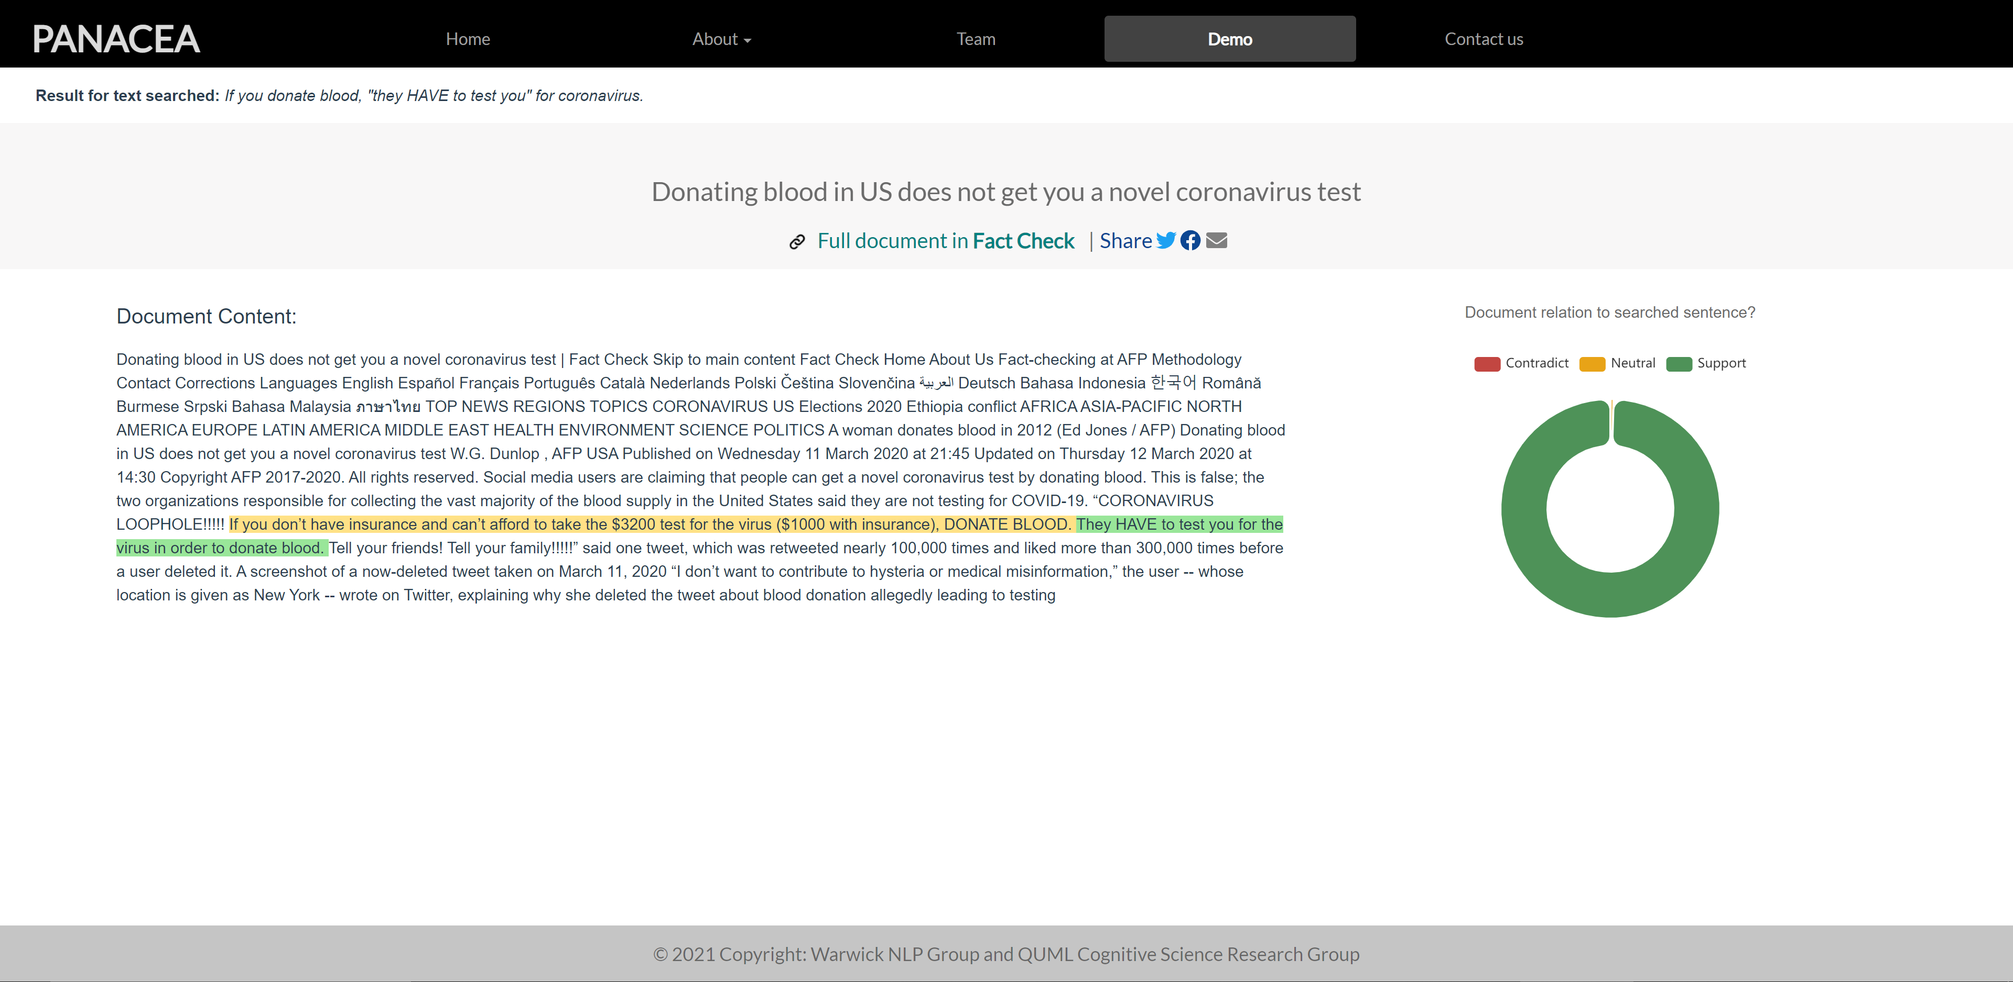

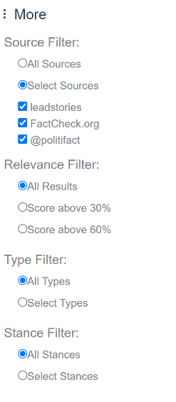**What are the functions provided?** 

c-2

e

a

b

d

c-1

1. Users could search a new claim they would like to check here. The previous searched claim is also kept in this box.
2. The overall altitude to the searching claim is displayed here.
3. Results filter, which users can choose whether the results are sorted by article or sentence. For advance filters, users could click the “More” button and choose to filter the results by source, relevance, type, and stance, as shown in c-2.
4. The result listed: if sort by article, it would show the related article title and representative sentences; if sort by sentence, it would show the sentence and its context.
5. Key information about the corresponding result, including type, source, relevant score, and stance.

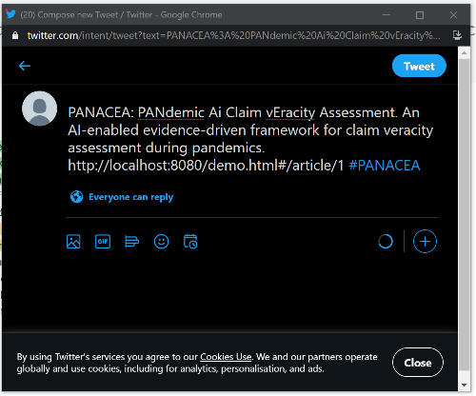

h

f

j

g

i-1

1. The text searched by user.
2. The article.

i-2

1. The link to the original page for this article.
2. The link to share current page to the main social media, after clicking it would pop out the window for sharing (as shown in i-2).
3. The pie chart showing the stance of current article to the text searched by user.

**Some use cases**.

1. *If you donate blood, "they HAVE to test you" for coronavirus.*

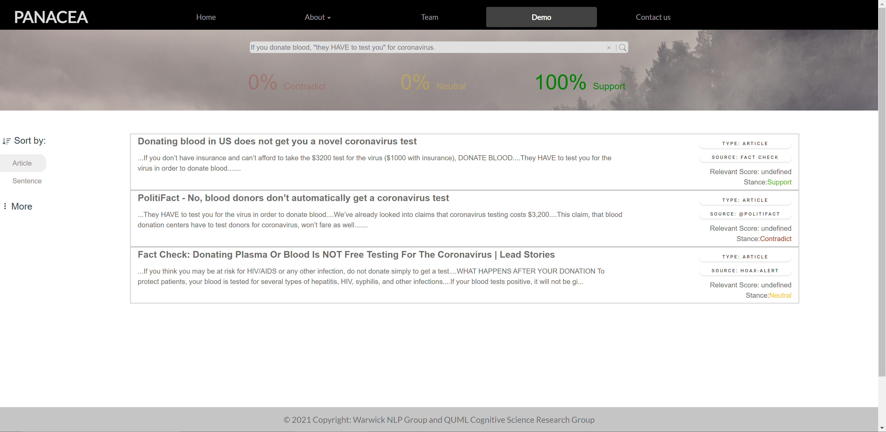

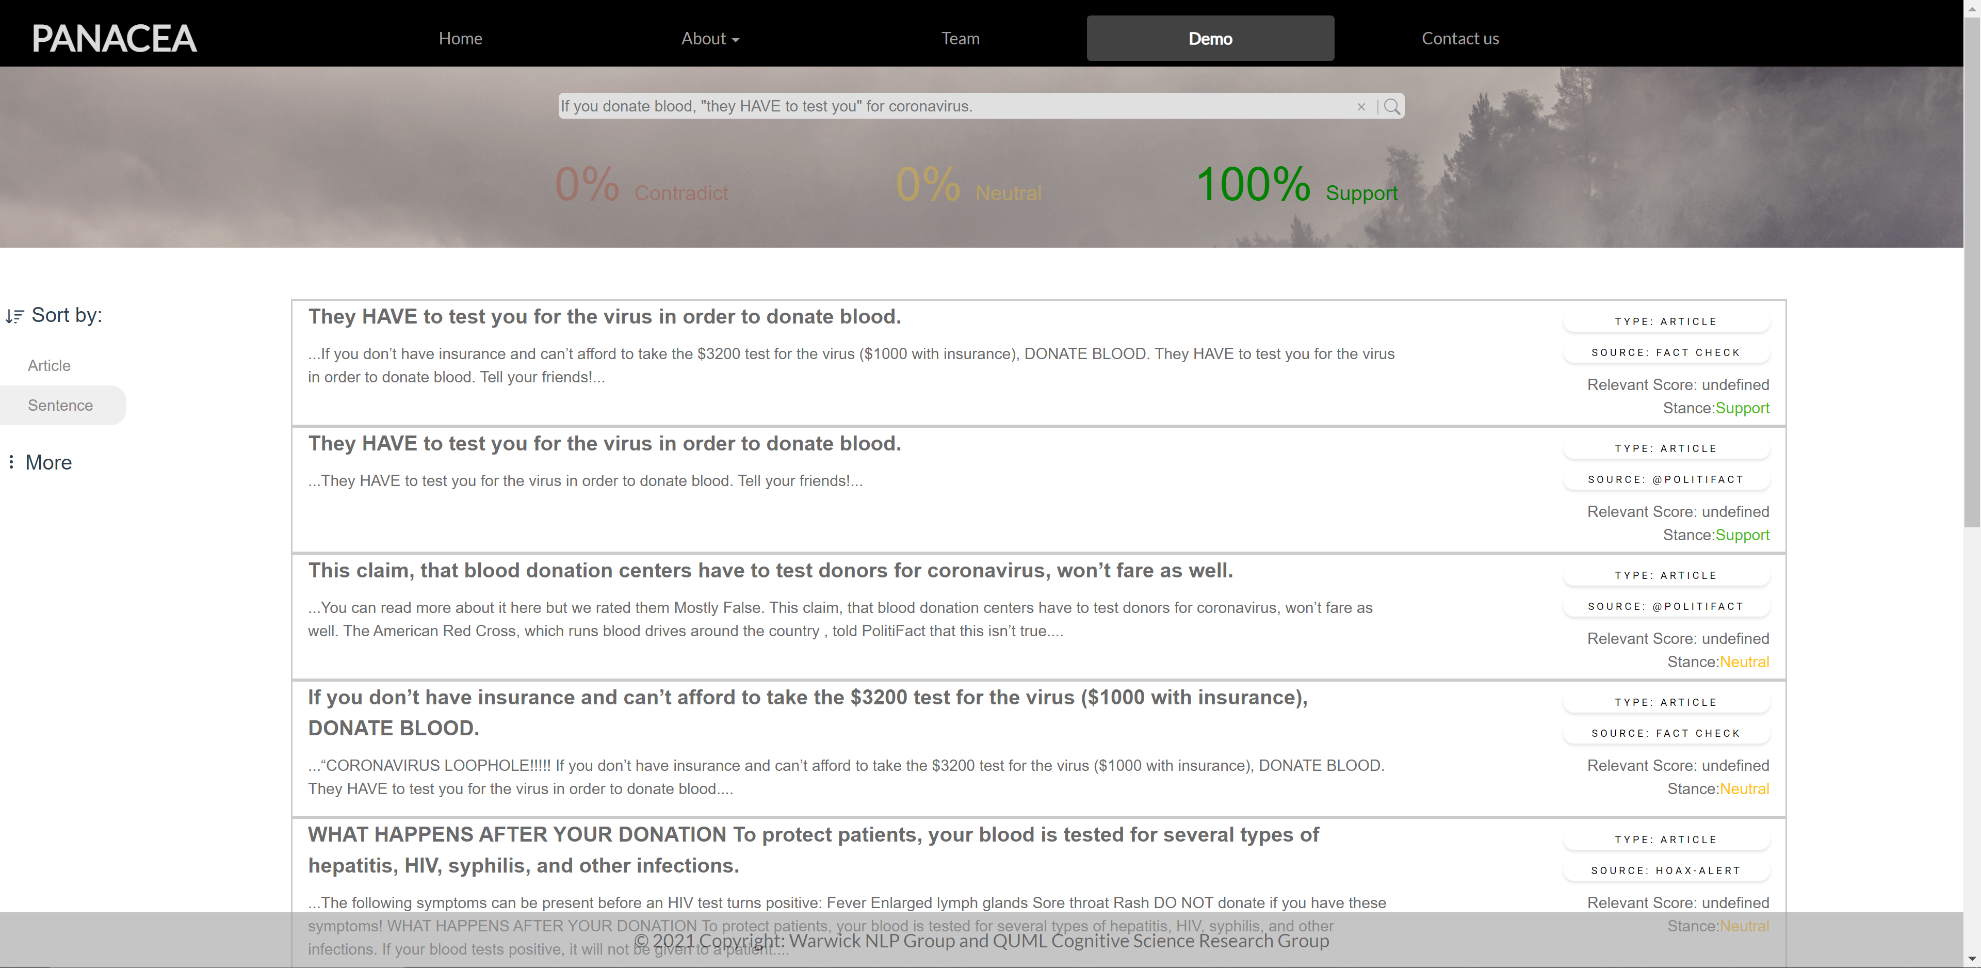

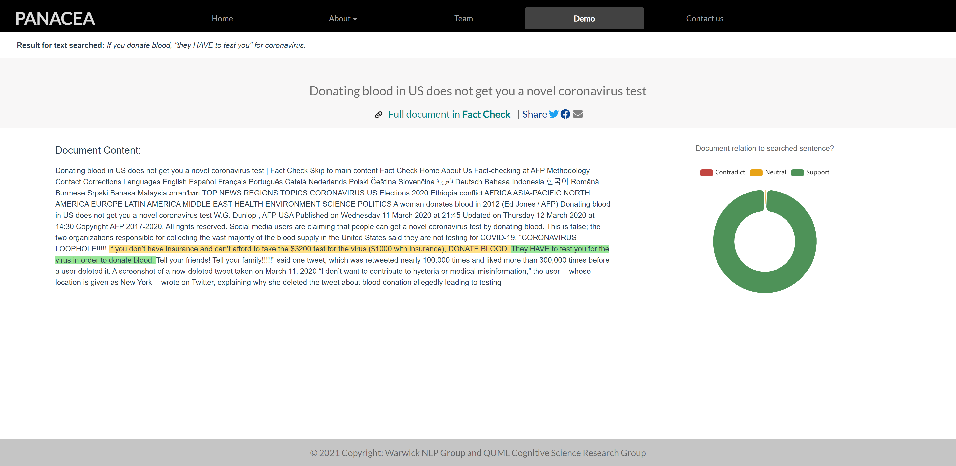

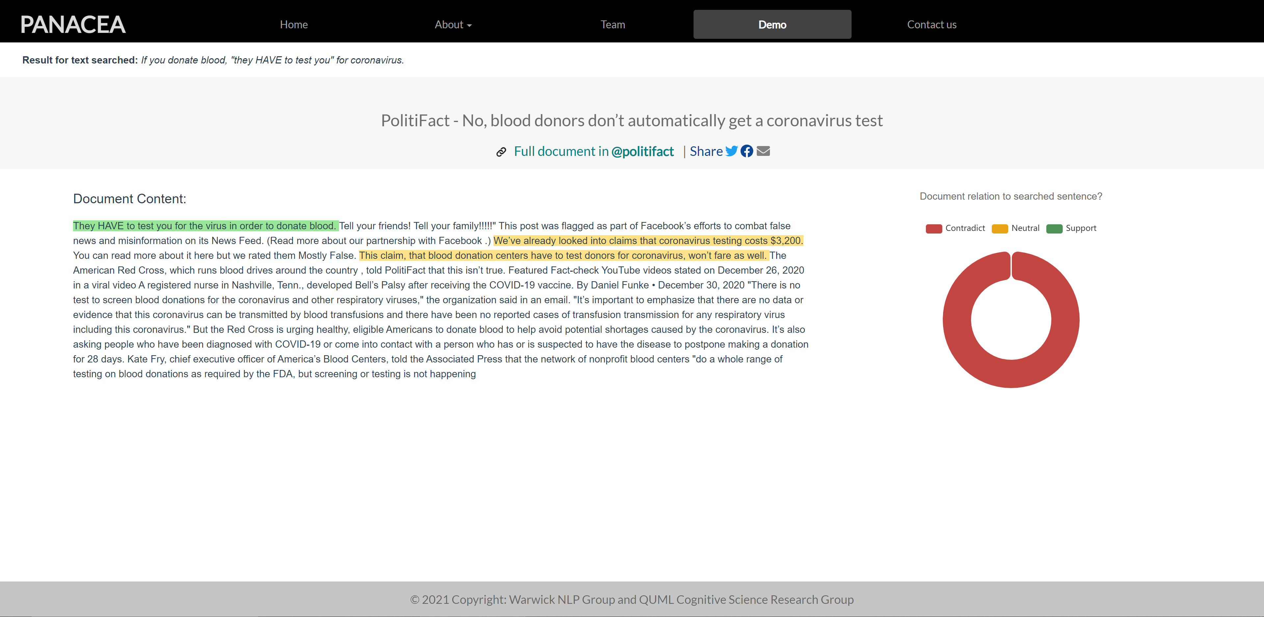

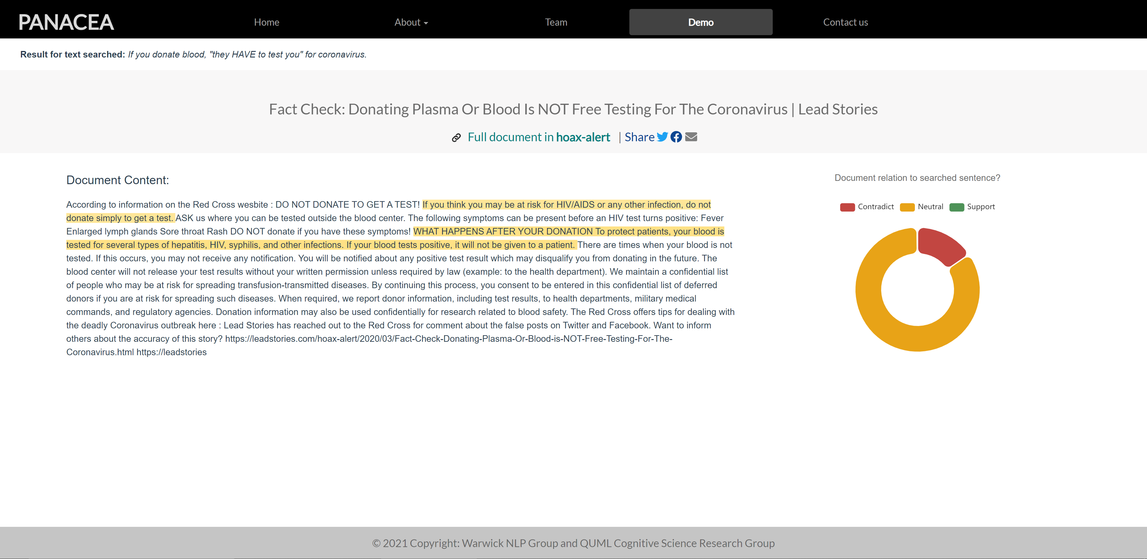

1. *Missouri students will have to repeat the school year because of COVID-19 school closings.*

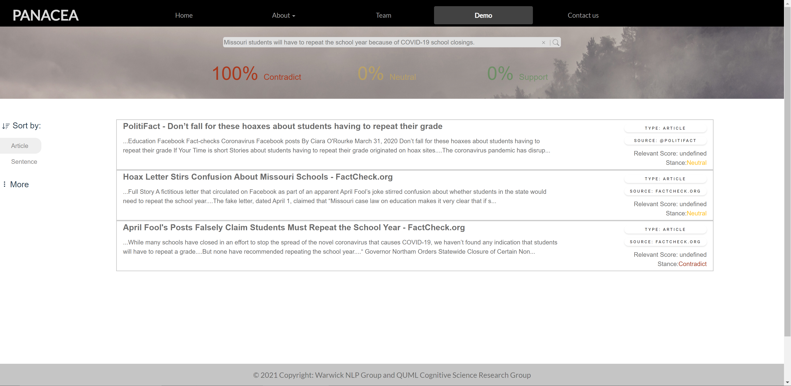

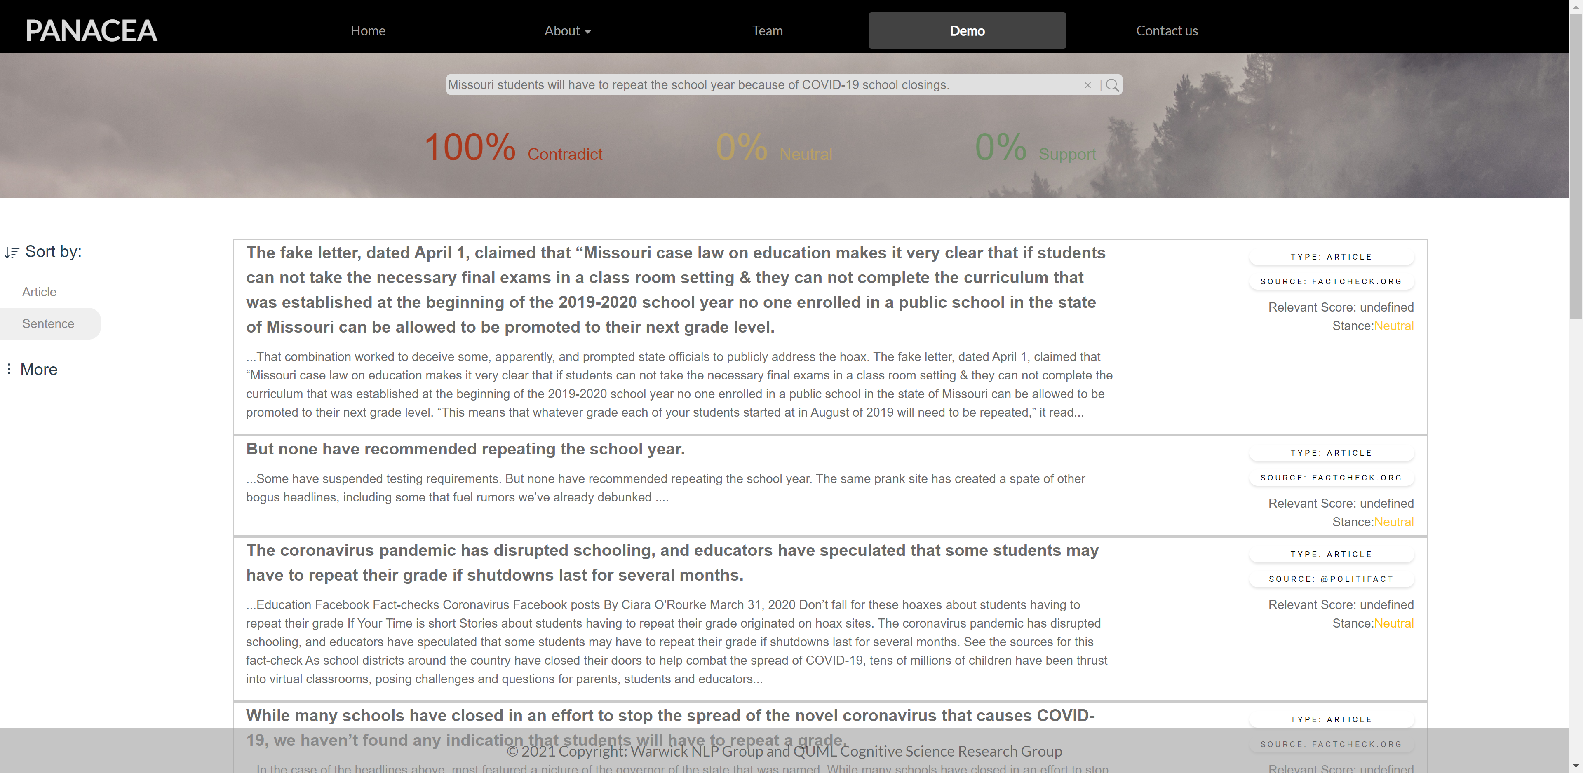

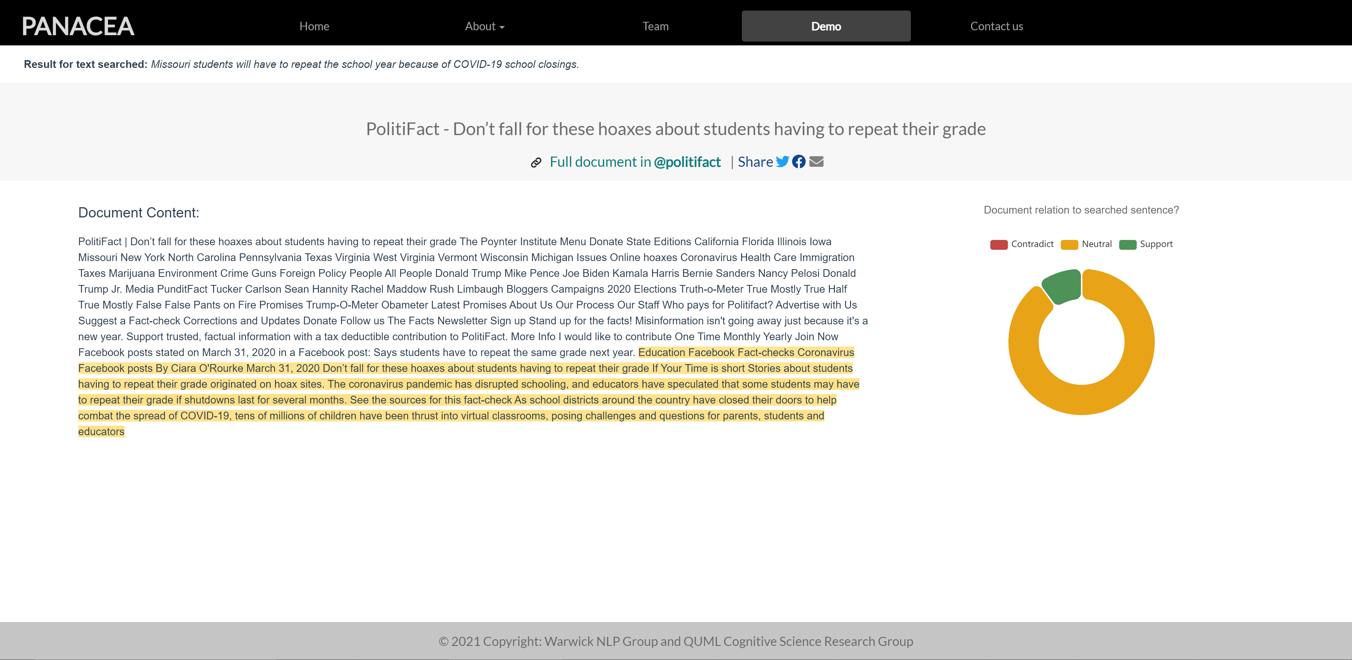

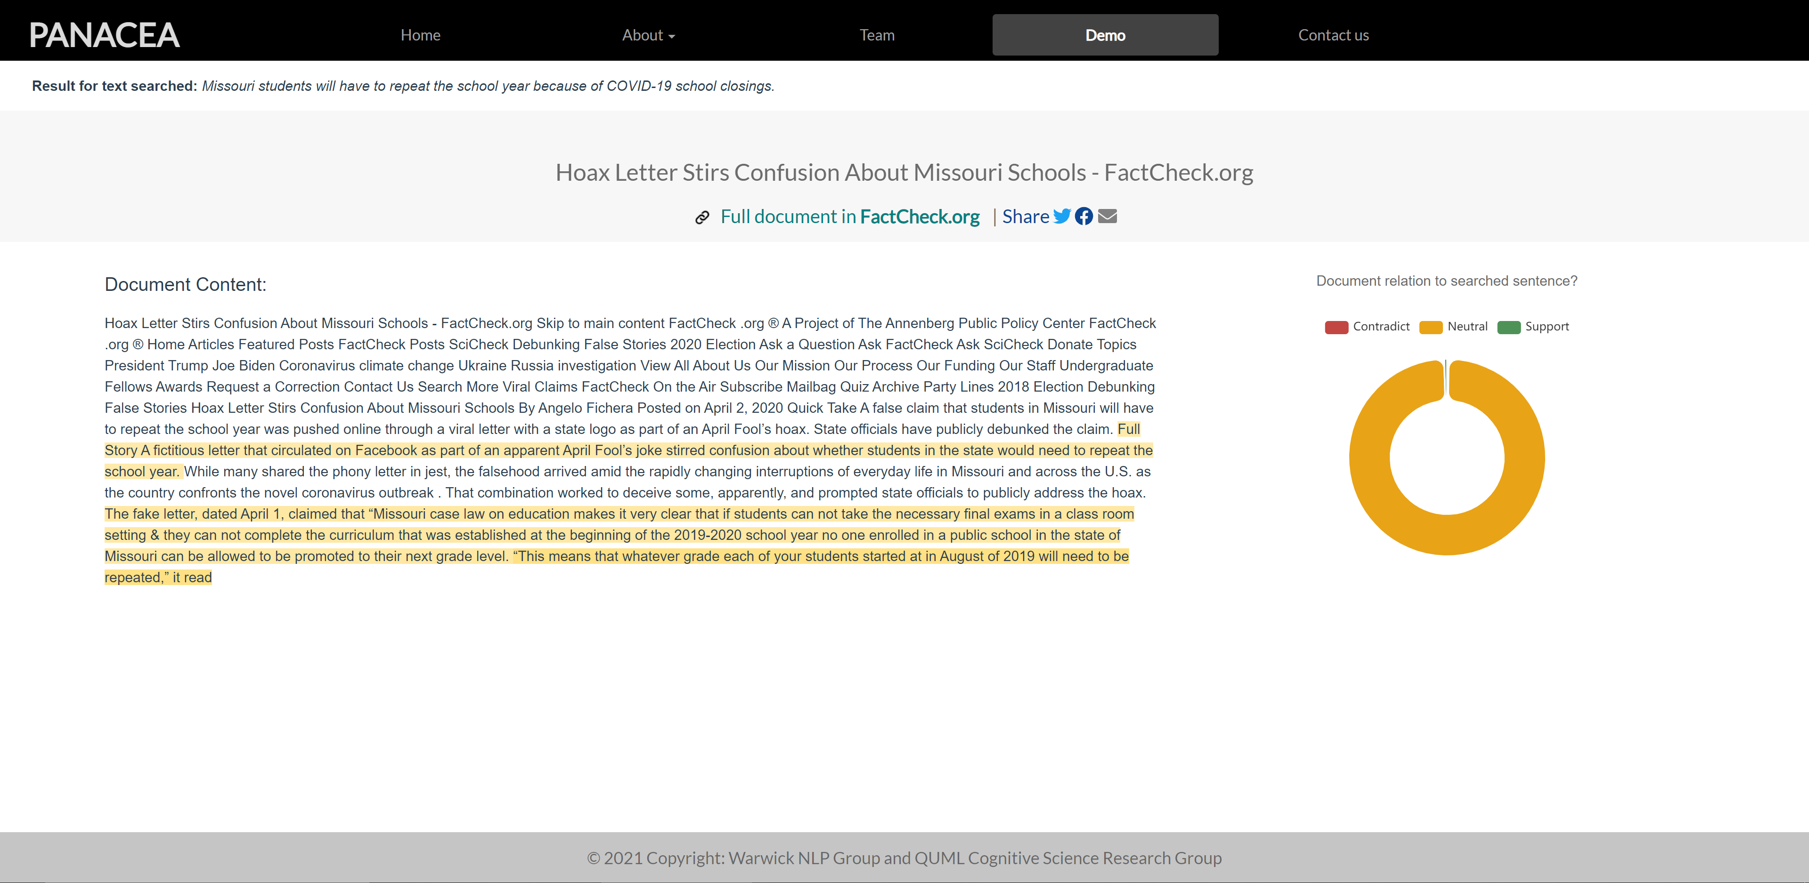

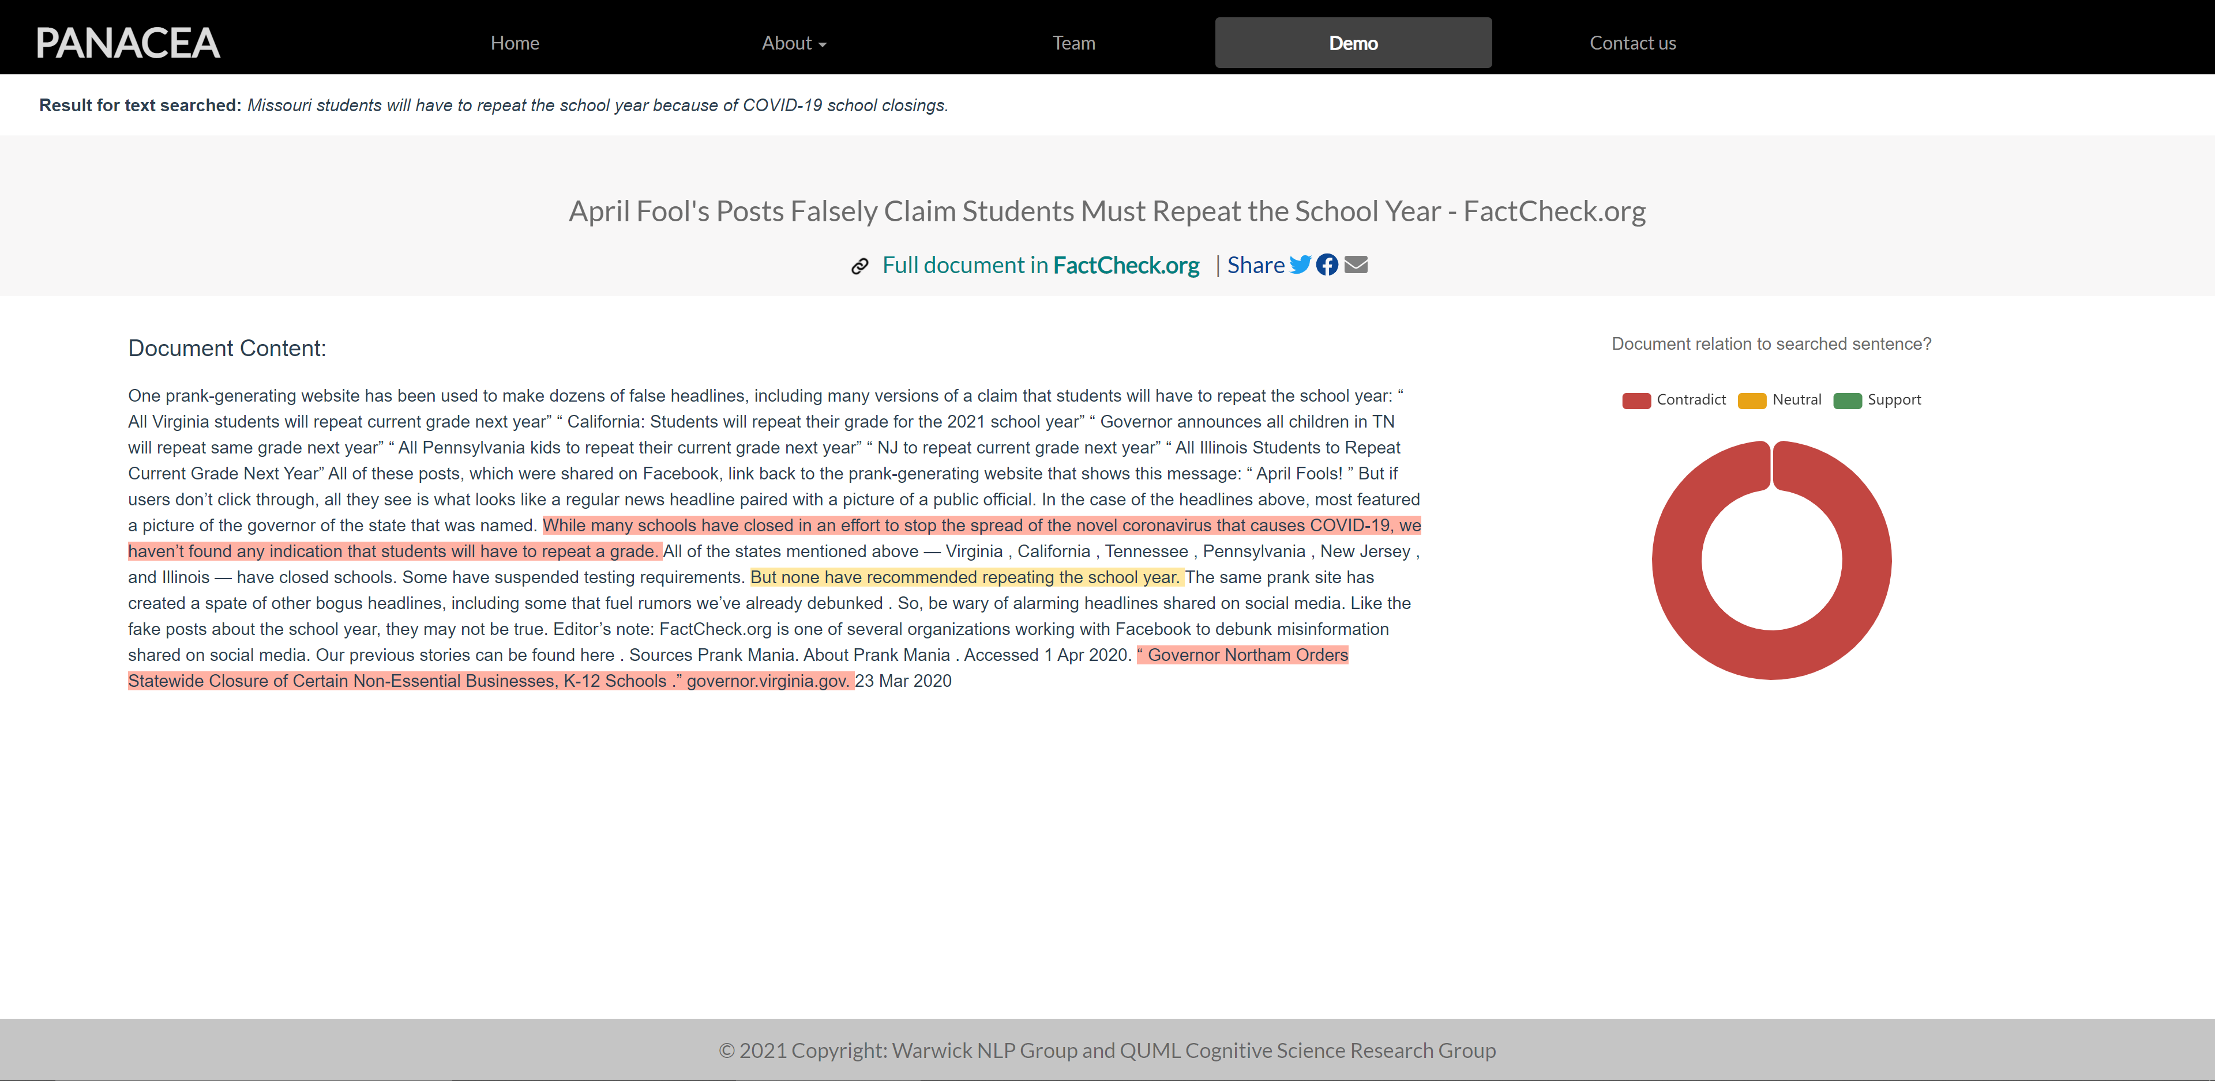

1. *House Speaker Nancy Pelosi was in Wuhan China six days after “the impeachment HOAX failed.”*

